Communication & Electronics Department

**Experiment (6): IP subnetting distribution**

Student Name : Abdelrahman Mahmoud Abdelrahman Mahmoud

Student Code : 125200238

Section Number : 2

Student Number in the registration statement :32

4th Computer & Control

Sec (2)

Dr/ Mohamed Abdelhamid

Objectives:

To implement subnetting and make configuration to Router using three modes for connect two LANs with each other .

Equipment / Program Requirements:

* Router
* Switches
* End devices

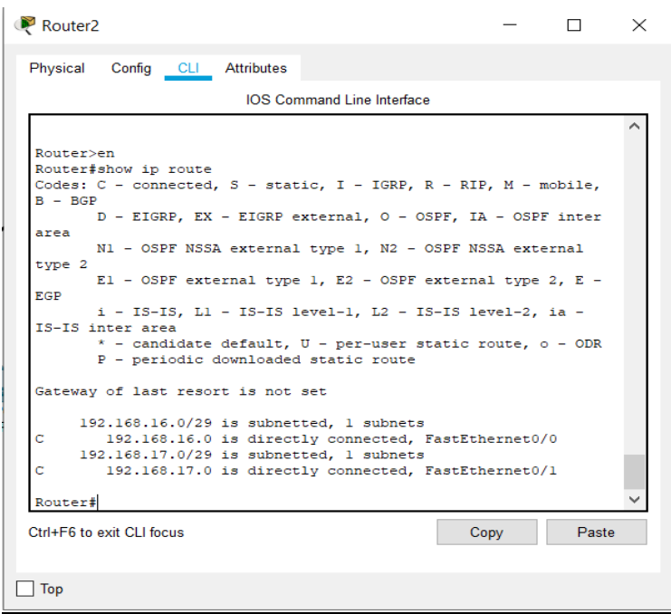

Class C

Network Address 192.168.16.0/24

Default subnet mask 255.255.255.0

**After subnetting :**

11111111. 11111111. 11111111.11111000

255.255.255.248

Network Address 192.168.16.0/29

Valid host Ip = 8-2 = 6

First valid Ip Address : 192.168.16.1

Last valid Ip Address : 192.168.16.6